CIRCUIT DIAGRAM :

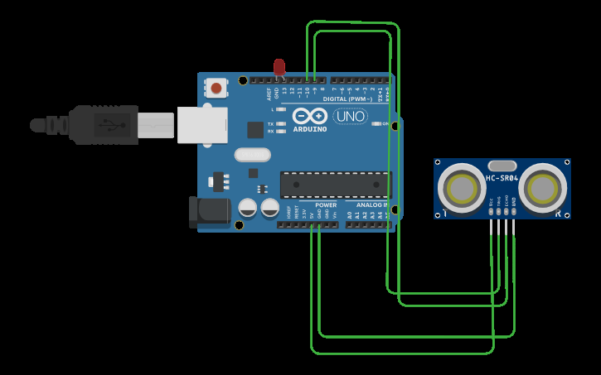

THEORY

CONCEPT USED:

The concept used in this experiment is that:-

Ultrasonic distance sensor determine the distance to an object by measuring the time taken by any obstacle coming towards the device or may be going away from sensor.

The devices used in this experiment by me are Arduino ,ultrasonic distance sensor,wires. The GND pin of Arduino board is used as ground.

LEARNING AND OBSERVATIONS:

LEARNING :

1. By doing this experiment I have learned how to make a home security system using Arduino and ultrasonic distance sensor.
2. I also learned making circuit using connection and some hardwares.
3. We also learned how to write a program and how to stimulate it.

OBSERVATIONS :

While doing this experiment we observe a pattern that when someone approaches the gate, then the LED starts blinking i.e when distance is less than 100 cm, otherwise it remains off .

PROBLEMS AND TROUBLESHOOTING :

The problems faced by me while during this experiment are:

1. LED was not working properly so I had to replace the LED.
2. I also faced the problem while setting the timings and delay timings.
3. Code was need to be examined very carefully.

PRECAUTION :

The precautions that we need to keep in mind while doing this experiment :

1. Firstly, connections and circuit should be cross checked carefully .
2. The circuit made should be neat and clean
3. The wires are inserted properly and tightly at the required points so that the circuit doesn’t get shorted
4. Connections should be done correctly

LEEARNING OUTCOMES :

1. Through this experiment I have gained the skill of making a circuit using different hardwares and controlling the functions done by that circuit with the help of code.
2. We also come to know about on what principle does the home security system works.